Insurance Claims Fraud Detection

Insurance claims fraud detection is a challenging problem, given the variety of fraud patterns and relatively small ratio of known frauds in typical samples. While building detection models, the savings from loss prevention needs to be balanced with cost of false alerts. Machine learning techniques allow for improving predictive accuracy, enabling loss control units to achieve higher coverage with low false positive rates. In this project, multiple machine learning techniques for fraud detection are presented and their performance on various data sets examined. The impact of feature engineering, encoding categorical value and parameter tweaking are explored with the objective of achieving superior predictive accuracy.
The insurance dataset can be classified into different categories of details like Months as customer, age, policy number, policy bind date, policy state, policy csl, policy deductable, policy annual premium, umbrella limit, insured zip, insured sex, insured education level, insured occupation, insured hobbies, insured relationship, capital gains, capital loss, incident date, incident type, collision type, incident severity, authorities contacted, incident state, incident city, incident location, incident hour of the day, number of vehicles involved, property damage, vehicle claim, auto make, auto model, auto year, fraud reported, c39. For better data exploration, we do some Exploratory Data Analysis (EDA) on all the datasets, some key insights are listed below.
Exploratory Data Analysis (EDA):
- Reading Data
- Checking null value
- Checking categorical value
- Drop unwanted column
- Data cleaning
- Features engineering
- Analysis of data
- Encoding categorical columns
- Data distribution
- Checking skewness
- Checking correlation of features
- Checking outliers
- Removing outliers
- Splitting data into features and target
- Handling class imbalance
- Data scaling
- Splitting data into train and test

Reading data:
For reading data we use pandas library.
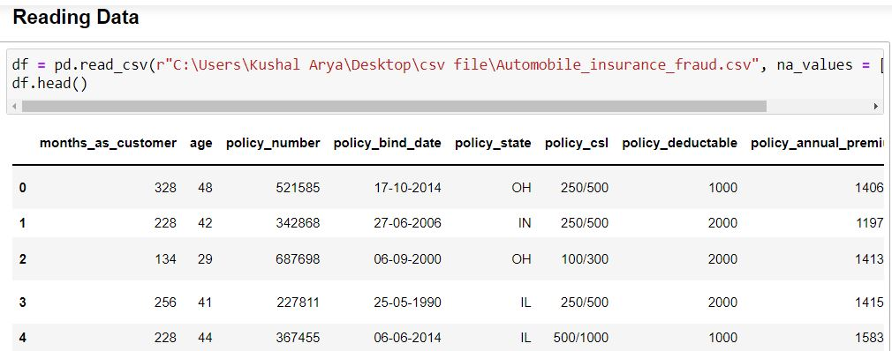

Checking null value:
Identify Nan we use ‘data.isna ().sum () ‘syntax.
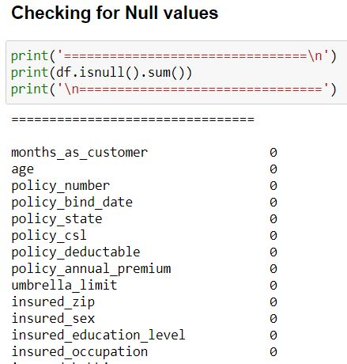
There are null values are found we treat them in later steps.
Checking categorical value:
To know about our data we use ‘data.info ()’ syntax.
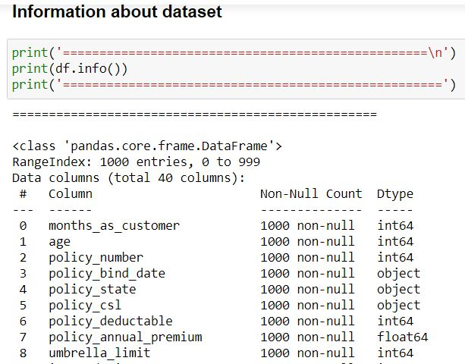

Categorical data present in our data set.

Data cleaning:
Dropping unwanted column and fill Nan with mean and mode.
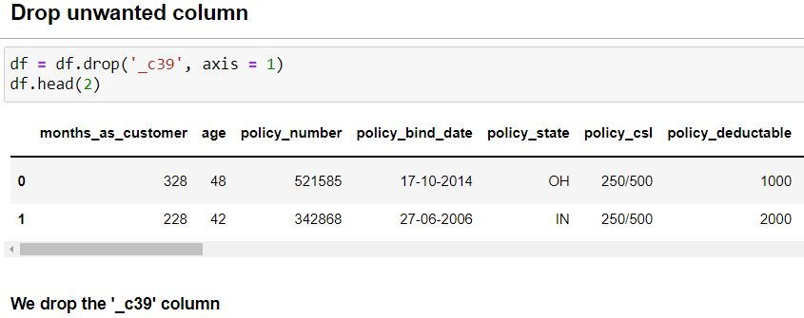
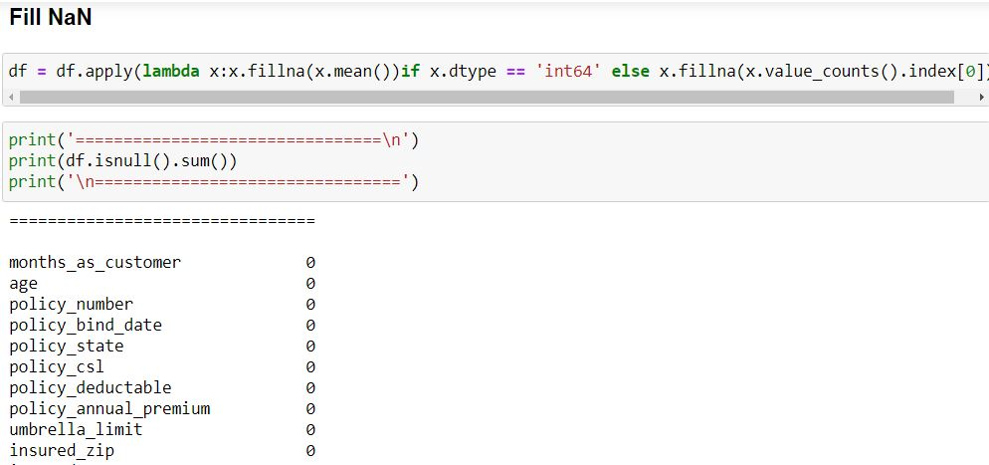
There is no Nan found in our data set.
Analysis of data:
Months as customer vs. Fraud Reported
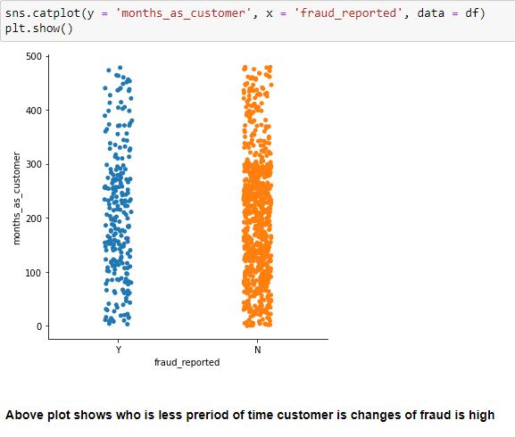
Age vs. Fraud Reported
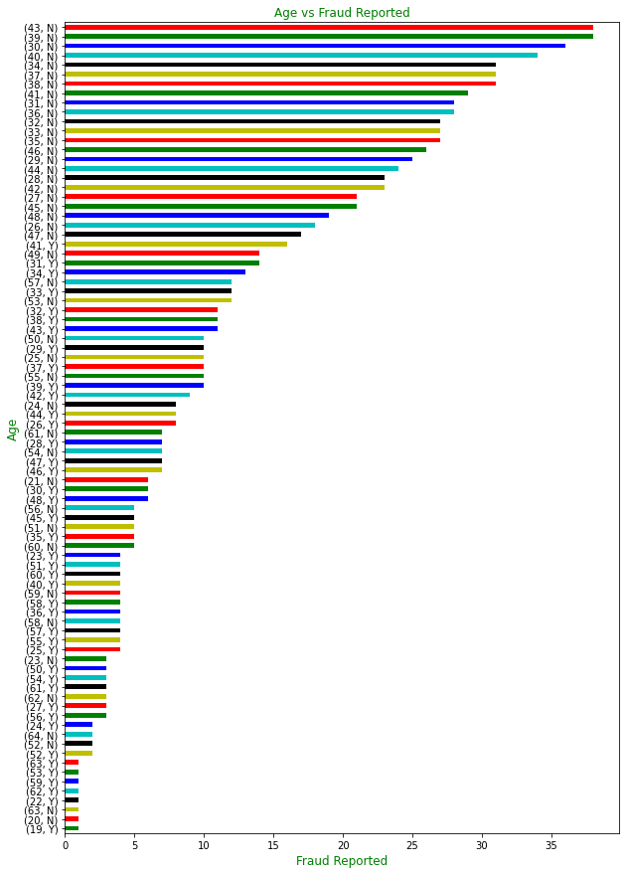

Age group 31 to 41 highest Fraud Reported.

Insured Sex vs. Fraud Reported

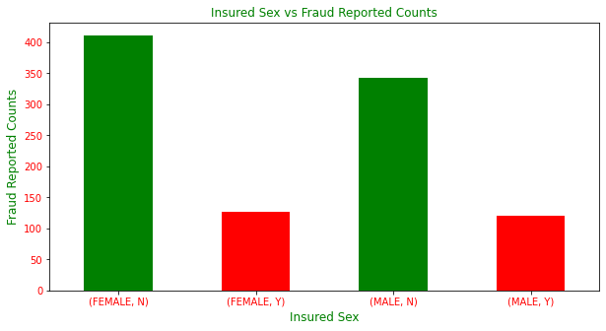

In female highest no of fraud reported.

Education vs. Fraud Reported
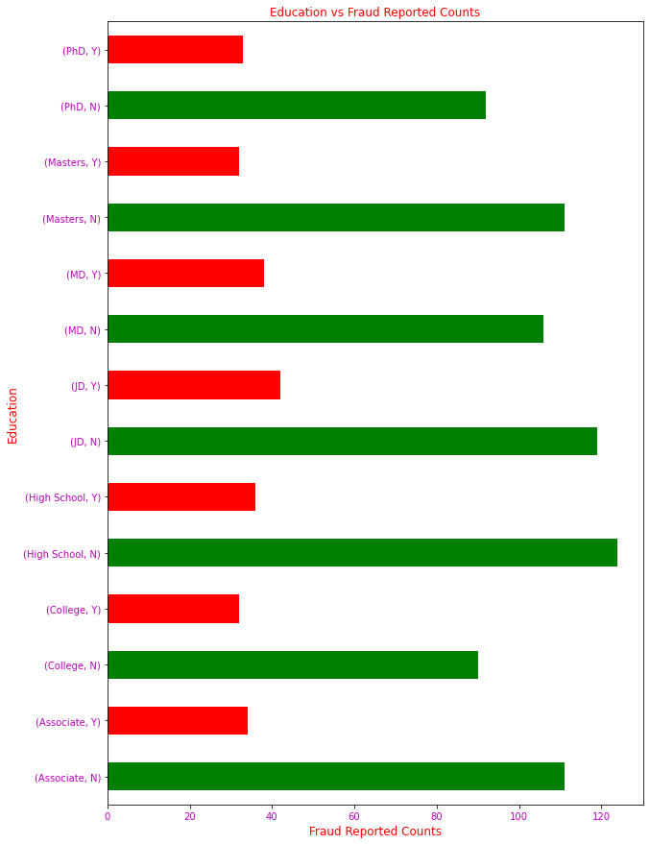

JD has highest fraud reported.

Incident Type Fraud vs. Fraud Reported

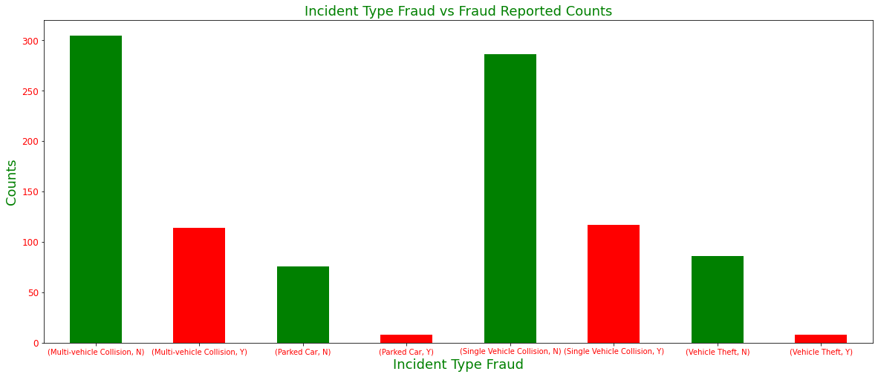

Single Vehicle Collision Highest Fraud Reported.

Incident State
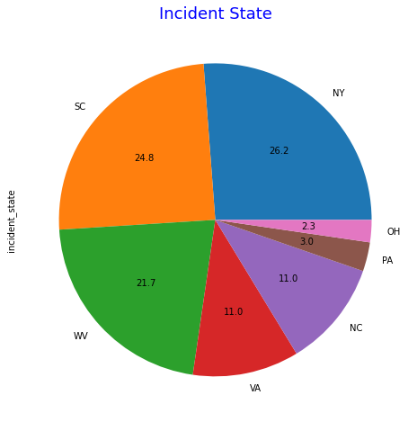

NY State has highest incident counts.

Vehicles Company vs. Counts

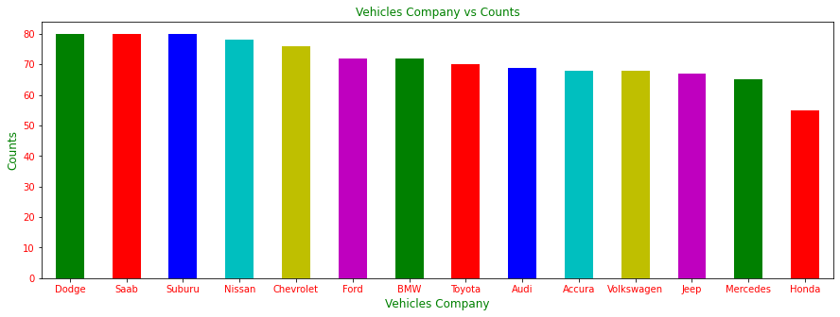

Dodge is highest counts and Honda is lowest.

Encoding Categorical Column:
In order to convert categorical value we use ordinal encoder.
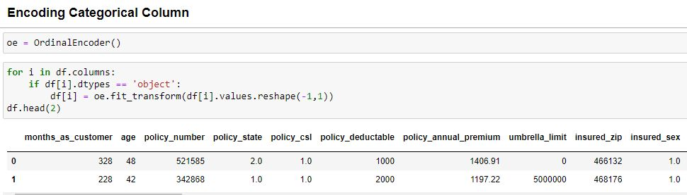

All categorical columns are encoded.

Data distribution:

Here we check how our data is distributed for this we use distribution plot.
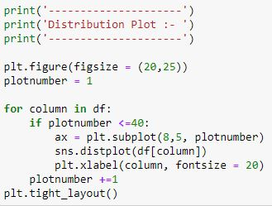
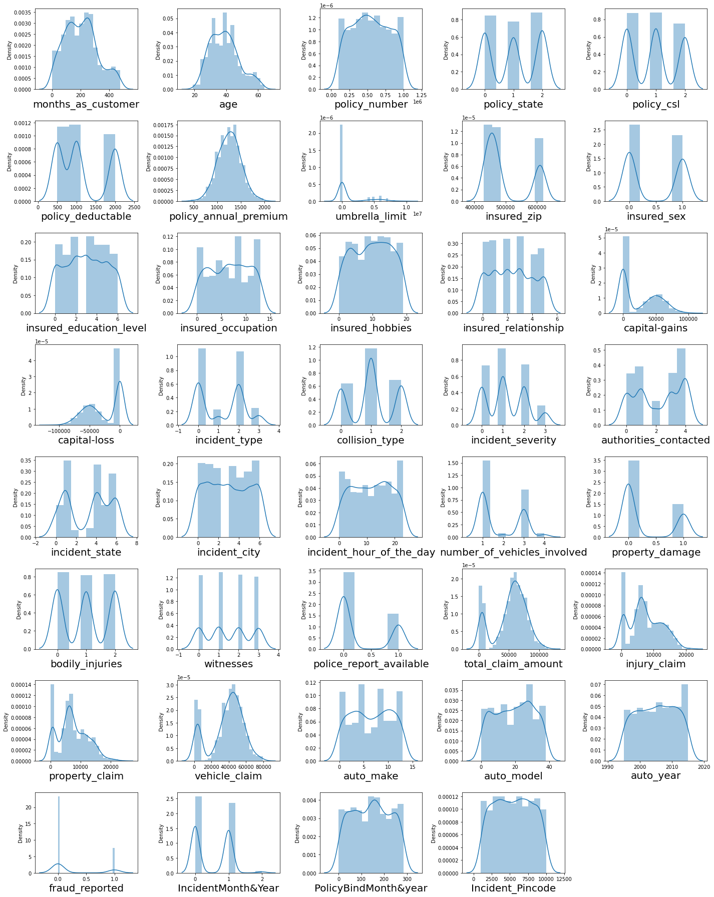

Some columns are little skewed.

Check skewness:
For checking we use ‘data.skew ()’ syntax.
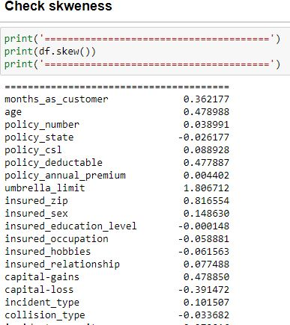

Skewness present in our dataset.

Correlation of Feature vs. Target:
In order to check correlation we use Heat Map.
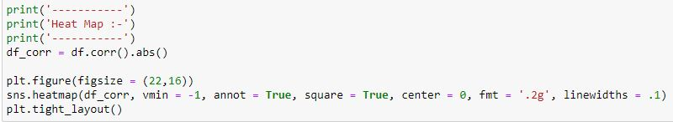
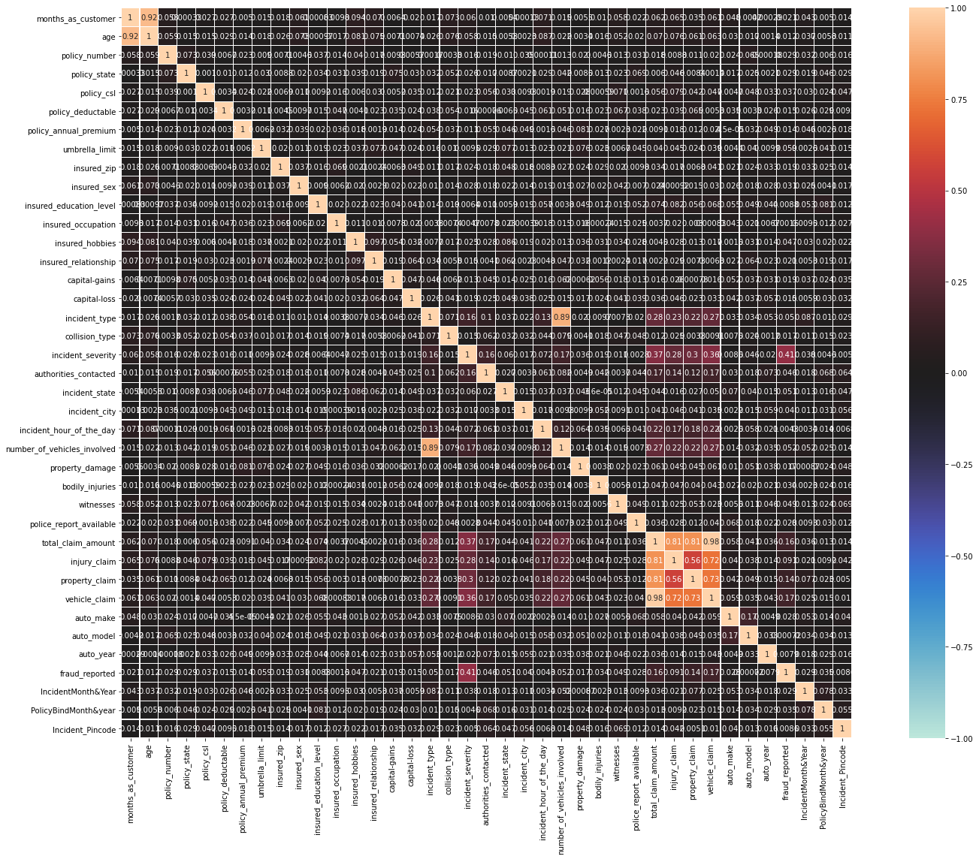

Vehicle Claim highest correlation.

Checking Outliers:
In order to check outliers we use box plot.
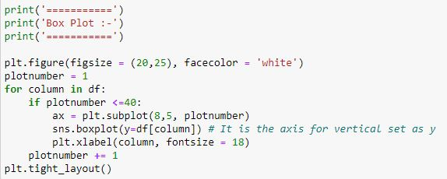
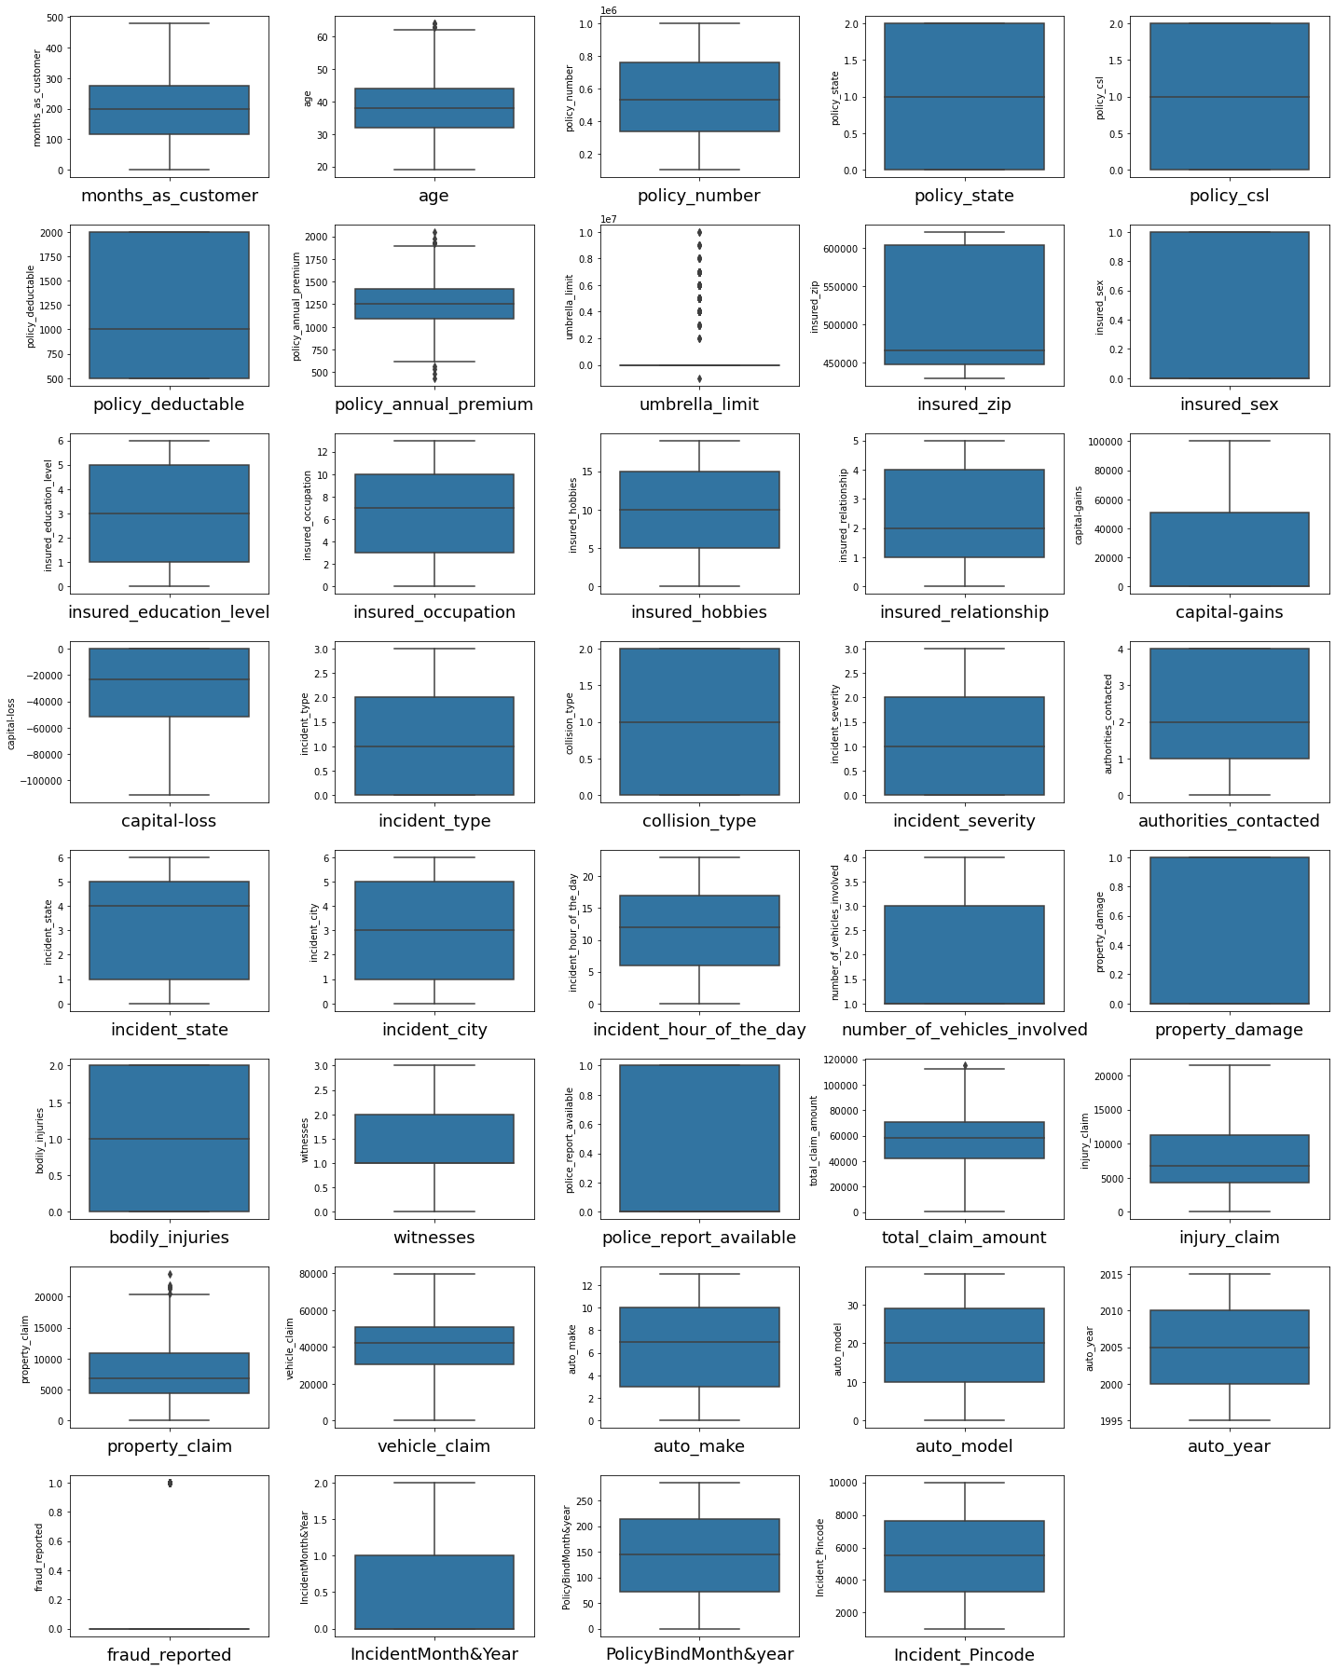

There are outliers presents in dataset.

Removing Outliers:
Removing outliers we use zscore it apply only on continuous value.
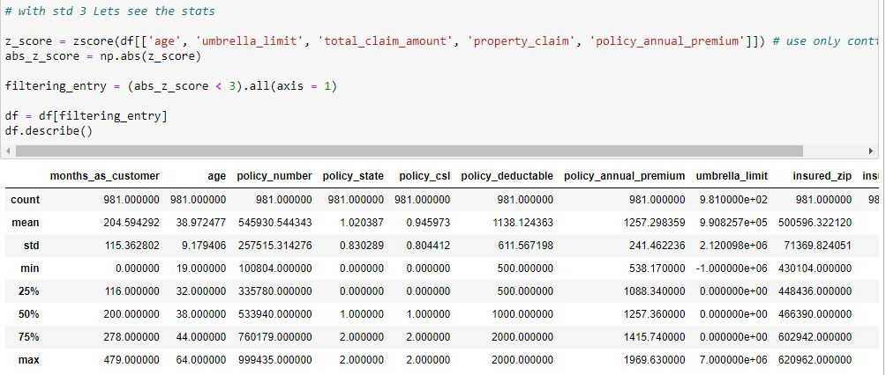

Outliers are removed.

Splitting Dataset into features and label:

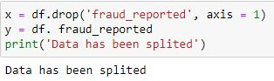

Handling Class Imbalance:
For handling class imbalance we use SMOTE.
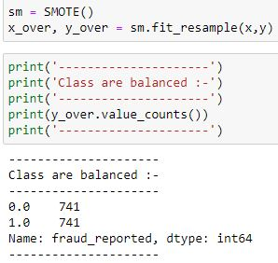

Data Scaling:

Scaling data we use Min Max Scaler.
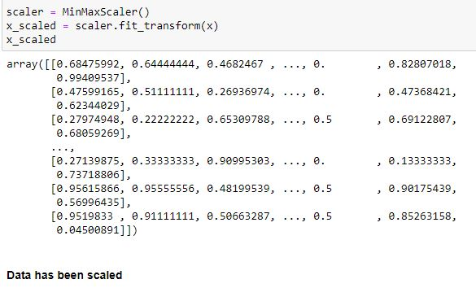

Split data into train and test:
Model Building:
The model building activity involves construction of machine learning algorithms that can learn from a dataset and make predictions on unseen data. Such algorithms operate by building a model from historical data in order to make predictions or decisions on the new unseen data.
The following steps are listed to summarize the process of the model development:
- Once the dataset is obtained and cleaned, different models are tested on it
- Based on the initial model performance, different features are engineered and re-tested
- Once all the features are engineered, the model is built and run using different fit values and using different iteration procedures (feature selection process)
- In order to improve model performance, do hyperparameter that affect the performance are tweaked and re-tested

Decision Tree Model:
We apply bagging over decision tree for evaluation check accuracy in classification report mode and to check model over fitting problem we perform cross validation.
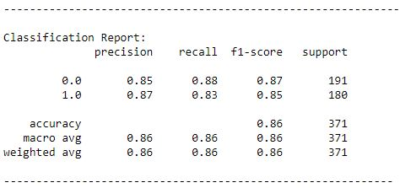

Conclusion: Decision Tree model has 86% accuracy score.

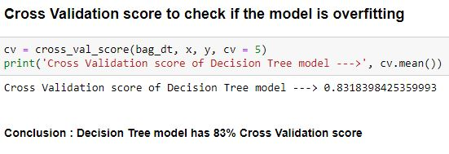

ROC, AUC Curve

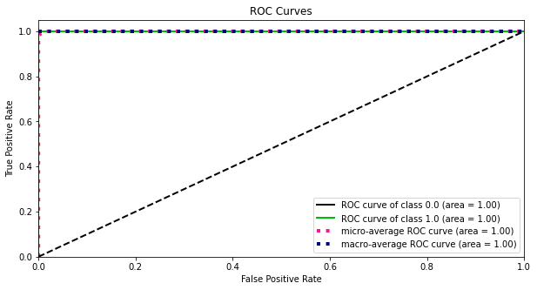

XGBoost Model:
We apply bagging over XGBoost for evaluation check accuracy in classification report mode and to check model over fitting problem we perform cross validation.
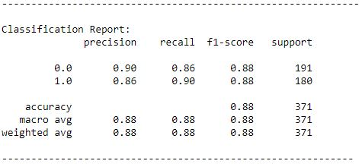

Conclusion: XGBoost model has 88% accuracy score.

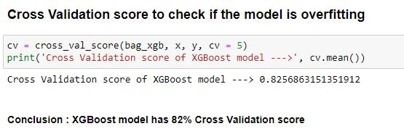

ROC, AUC Curve
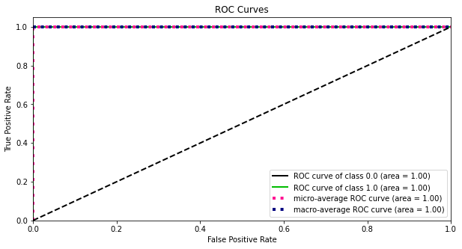

KNeighbors Model:
We apply bagging over KNeighbors Model for evaluation check accuracy in classification report mode and to check model over fitting problem we perform cross validation.
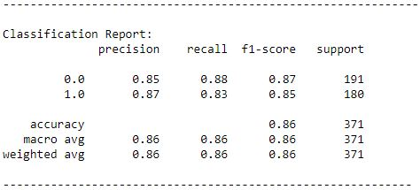

Conclusion: KNeighbors model has 86% accuracy score.

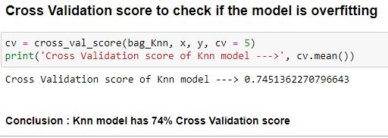

ROC, AUC Curve
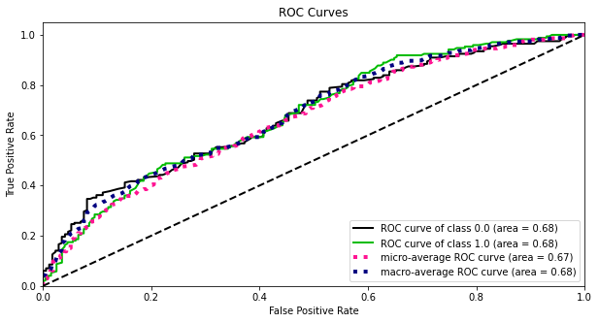

Random Forest Model:
We apply bagging over Random Forest Model for evaluation check accuracy in classification report mode and to check model over fitting problem we perform cross validation.
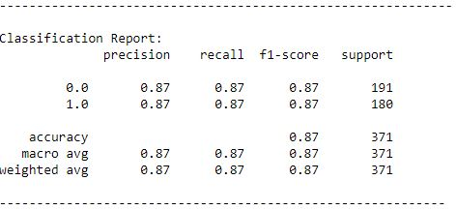

Conclusion: Random Forest model has 87% accuracy score.

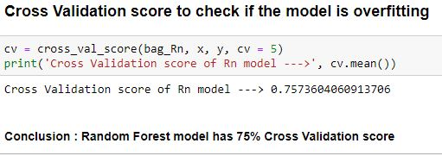

ROC, AUC Curve

Logistic Regression Model:
We apply bagging over Logistic Regression Model for evaluation check accuracy in classification report mode and to check model over fitting problem we perform cross validation.
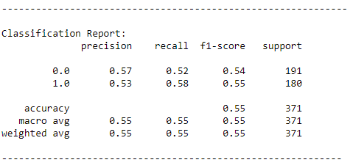

Conclusion: Logistic Regression model has 55% accuracy score.

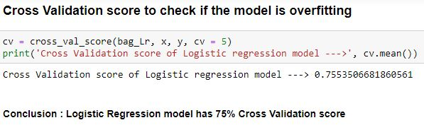

ROC, AUC Curve

Let's check ROC, AUC Curve for the fitted model:

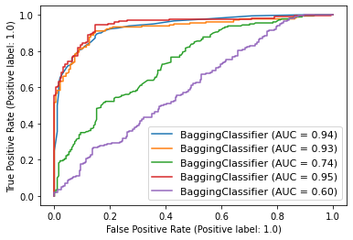

Looking ROC, AUC Curve we found Random Forest has best model so we do Hyperparameter Tuning on it.

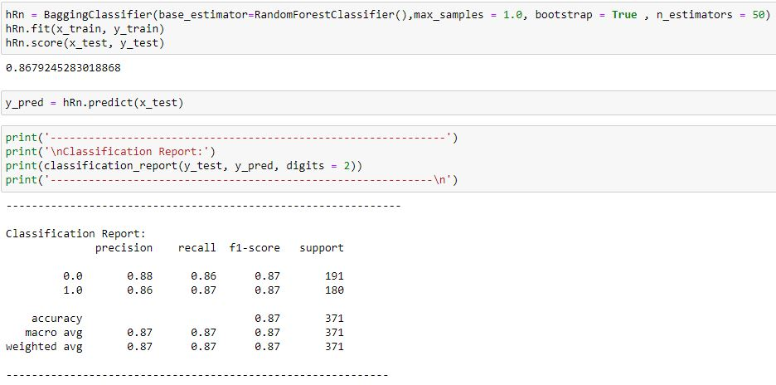

After Hyperparameter Tuning model accuracy score 87%.

Saving the Model:

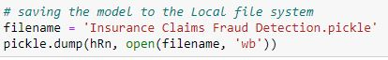

Predict Insurance Claims Fraud Detection:

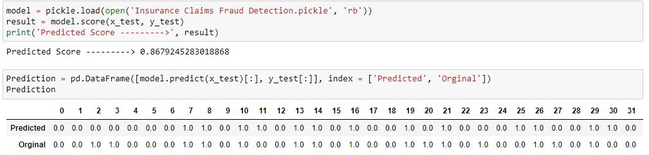

Saving the predicted result in CSV file:

Final Conclusion: Random Forest is our best model.

